**Acknowledgement and Assignment Agreement**

In consideration of my employment by **Softcrylic LLC** ("Company"), and the compensation paid to me by the Company from time to time, I hereby represent to and agree with the Company as follows:

1. I understand that the Company is in the business of providing software development and engineering services to third parties (each, a “Client”) and that, while employed by the Company, I will be expected to work on projects and software programs of and belonging to Clients. I also understand that Clients are engaged in continuous programs of research, development, production and marketing with respect to present and future systems, programs and products related to their respective businesses. I further understand that, as an essential part of my employment by the Company, I am expected to make new contributions to and create inventions of value for Clients. Moreover, I understand that the Company must, as a condition to obtaining assignments from Clients, undertake to ensure that the Client owns all right, title and interest in and to any inventions and other original work and to any improvements, enhancements or other development of or relating to existing software, programs or other property, and in connection therewith will assign its rights in and to any such inventions, original work and developments to its Clients.

2. I represent that I have not brought and will not bring with me to the Company or use in the performance of my responsibilities at the Company any materials or documents of a former employer which are not generally available to the public, unless I have first obtained written authorization from the former employer for their possession and use, which written authorization I will deliver to the Company on or before my use of such materials or documents.

3. I understand that my employment by the Company creates a relationship of confidence and trust between me and the Company with respect to any information of a confidential or secret nature that may be learned or developed by me during the period of my employment by the Company and which (i) relates to the business of the Company or any Client, or (ii) has been created, discovered or developed by, or has otherwise become known to the Company or its Clients and has commercial value in the business in which the Company or its Clients are engaged (hereinafter called "Proprietary Information"). By way of illustration, but not limitation, Proprietary Information includes trade secrets, processes, formulas, computer programs, data, know-how, inventions, improvements, techniques, marketing plans, product plans, strategies, forecasts, personnel information and customer lists. I understand that Company is contractually obligated to protect the Proprietary Information of Clients, and that any disclosure or use of Proprietary Information belonging or pertaining to any Client would be a violation of my duty to loyalty to Company as my employer.

4. All Proprietary Information shall be the sole property of the Company or its Clients, as the case may be. I hereby assign to the Company any rights I may have or acquire in all Proprietary Information. I understand that the Company may, as a condition to obtaining assignments from Clients, re-assign to Clients any such Proprietary Information pertaining to that Client. At all times, both during the entire period of my employment and after its termination, I will keep in confidence and trust all Proprietary Information, and I will not use or disclose any Proprietary Information without the prior written consent of the Company or the Client, as the Company’s assignee, except as may be necessary in the ordinary course of performing my duties as an employee of the Company. In addition, I understand that I am only to access, use and disclose Proprietary Information that is necessary for me to have in the course of performing my duties, and that I am not to disclose Proprietary Information to other employees or contractors at Company or Client unless it is necessary for those employees or contractors to have such Proprietary Information in the course of their duties. In the event of the termination of my employment, for any reason, I will promptly deliver to the Company all materials, documents and data of any nature containing or pertaining to any Proprietary Information and I will not take with me any such materials, documents or data or any reproduction thereof, provided that any Proprietary Information that pertains to a Client shall be delivered to that Client, as the Company’s assignee, and not to the Company itself.

5. I will promptly disclose in confidence to the Company or the Client, as the case may be, all Inventions that are made or conceived or first reduced to practice by me during the entire period of my employment with the Company or, in the case of any Client, my work on any assignment for that Client (or thereafter if Invention uses Proprietary Information of the Company or Client). For the purposes of this Agreement, “Inventions” means all inventions, improvements, original works of authorship, formulas, processes, ideas, innovations, concepts, proposed trademarks, computer programs, techniques, know-how and data, whether or not patentable or copyrightable, made or conceived or first reduced to practice or learned by me, whether or not in the course of my employment.

6. I agree that all Inventions that are made or conceived or first reduced to practice by me during the entire period of my employment with the Company or assignment for a Client (or thereafter if Invention uses Proprietary Information of the Company or the Client) shall be the sole and exclusive property of the Company or Client, as the case may be, and the Company or the Client, as Company’s assignee, shall have the right to use and/or to apply for patents, copyright registrations or other statutory or common law protections for such Inventions in any and all countries. I further agree to assist the Company or the Client, as Company’s assignee, in every proper way (but at the expense of the Company or the Client, as the case may be) to obtain and from time to time enforce patents, copyrights and other statutory or common law protections for such Inventions in any and all countries. To that end, I will execute all documents for use in applying for and obtaining such patents, copyrights and other statutory or common law protections therefore and enforcing same, as the Company or the Client, as the Company’s assignee, may desire, together with any assignments thereof to the Company or Client or to persons designated by the Company or Client, as the case may be. If any Moral Rights under any applicable law arise in respect of any such Inventions, I hereby irrevocably transfer and assign to Company or Client, as the Company’s assignee, any and all of those Moral Rights. I also hereby forever waive and agree never to assert any and all of those Moral Rights. For purposes of this subsection, “***Moral Rights***” means any rights of paternity or integrity, any right to claim authorship in the Inventions that are made or conceived or first reduced to practice by me on or after the date specified in Section 16 below, and during the entire period of my employment with the Company or assignment for a Client (or thereafter if Invention uses Proprietary Information of the Company or the Client), to object to any distortion, mutilation or other modification of, or other derogatory action in relation thereto, whether or not such would be prejudicial to my honor or reputation, and any similar right, existing under judicial or statutory law of any country in the world, or under any treaty, regardless whether or not such right is denominated or generally referred to as a “moral” right. My obligations under this Paragraph 6 shall continue beyond the termination of my employment with the Company, but the Company or Client, as the Company’s assignee, shall compensate me at a reasonable rate after such termination for time actually spent by me at the request of the Company or the Client, as the case may be, on such assistance.

7. The provisions of Paragraph 6 above do not apply to an Invention for which all of the following are true

(a) The Invention was developed entirely on my own time;

(b) I developed the Invention away from the facilities of the Company and all Clients, and entirely without using the equipment, supplies or trade secret information of the Company or any Client;

(c) The Invention does not relate to the business or any anticipated research or development of the Company or any Client; and

(d) The Invention does not result from, and is not the extension of, any work done by me for the Company, either directly or on behalf of any Client.

8. I represent that I have reviewed, and hereby agree to comply with, the following posted policies of Client: Computer Use Policy, Data Classification Policy, Data Handling, Encryption Policy, Password Management Policy and Security Incident Policy.

9. I represent that my entering into and performing the terms of this Agreement does not and will not breach any agreement to keep in confidence proprietary information acquired by me in confidence prior to my employment with the Company. I agree not to enter into any agreement either written or oral in conflict herewith. I hereby authorize the Company to make known the terms of this Agreement and the fact of my responsibility hereunder to any Client.

10. I understand that my breach of this Agreement may cause the Company or the Client, as Company’s assignee, irreparable harm which may not be adequately compensated by money damages. Accordingly, in the event of a breach or threatened breach by me of this Agreement, the Company or the Client, as the case may be, shall be entitled to injunctive or other preliminary or equitable relief, without the requirement of posting a bond, in addition to such other remedies as may be available to the Company or the Client for such breach or threatened breach, including the recovery of damages.

11. I hereby irrevocably consent to the assignment by Company of all the rights, powers and privileges set forth herein to a Client, in so far as they relate to any assignment for that Client on which I may be directed to work while employed by the Company, or any Inventions that may result from or occur during such an assignment, and all Proprietary Information pertaining to that Client. I acknowledge that the Client for any project to which I am assigned is a third-party beneficiary of this Agreement, and may enforce this Agreement as fully as if it were a party hereto, and that this Agreement may not, for so long as I am assigned to that Client’s project, be modified or terminated without the prior written consent of the Client, any purported modification or termination hereof without such consent to be void and of no effect.

IN WITNESS WHEREOF, I have executed this Acknowledgement and Assignment Agreement, intending to be legally bound, as of date set forth below.

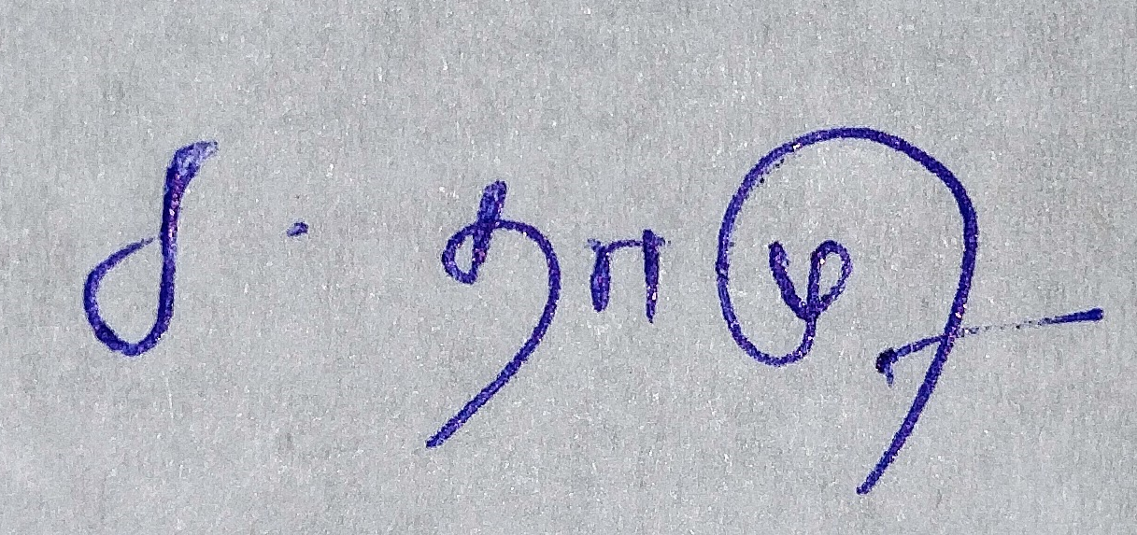

________________________________________

***Signature***

THAMOTHARAN C

_______________________________________

***Thamotharan C***

***08.05.2023***

_______________________________________

***Date***